ALV

OO-ALV

alv html 表头

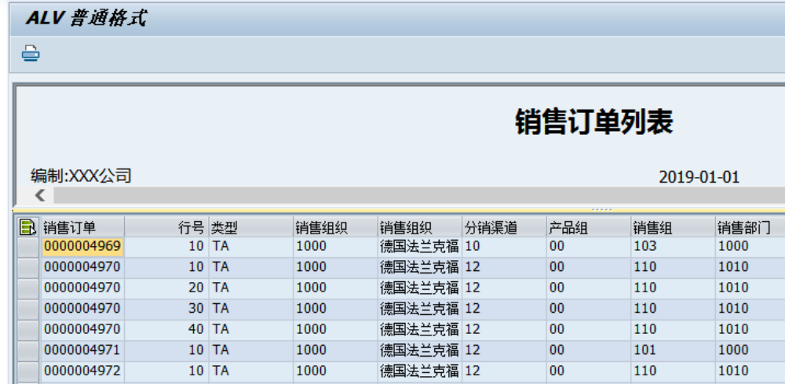

CALL FUNCTION 'REUSE_ALV_GRID_DISPLAY'
EXPORTING
I_CALLBACK_PROGRAM = SY-REPID
I_CALLBACK_PF_STATUS_SET = 'FRM_SET_PF_STATUS'
I_CALLBACK_USER_COMMAND = 'FRM_USER_COMMAND'
I_CALLBACK_HTML_TOP_OF_PAGE = 'FRM_HTML_TOP'
IS_LAYOUT = GS_LAYOUT
IT_FIELDCAT = GT_FCAT[]
TABLES
T_OUTTAB = GT_DATA[]
EXCEPTIONS
PROGRAM_ERROR = 1
OTHERS = 2
.
IF SY-SUBRC <> 0.
* Implement suitable error handling here
MESSAGE E001(00) WITH 'ALV 展示错误'.
ENDIF.

*&---------------------------------------------------------------------*
*& Form FRM_HTML_TOP
*&---------------------------------------------------------------------*
* text
*----------------------------------------------------------------------*
* -->CL_DD text
*----------------------------------------------------------------------*
FORM FRM_HTML_TOP USING CL_DD TYPE REF TO CL_DD_DOCUMENT.
DATA: M_P TYPE I.
DATA: M_BUFF TYPE STRING.
DATA: LV_COMPANY LIKE T001-BUTXT,
LV_MONTH(02) TYPE C,
LV_DAY(02) TYPE C.
DATA: LV_YEAR TYPE F.
LV_YEAR = '2012'."P_ZYEAR.
*表头其实完全可以是一个html文件，自己使用html语言进行格式控制
M_BUFF = '<html>'.
CALL METHOD CL_DD->HTML_INSERT
EXPORTING
CONTENTS = M_BUFF
CHANGING
POSITION = M_P.
M_BUFF = '<center><H2>销售订单列表</H2></center>'.
CALL METHOD CL_DD->HTML_INSERT
EXPORTING
CONTENTS = M_BUFF
CHANGING
POSITION = M_P.
CONCATENATE '<table width="1200"><tr><td width="480">编制:XXX公司' '</td><td width="250"><div align="center">2019-01-01</div></td><td width="454"><div align="right">单位:人民币元</div></td></tr></table>' INTO M_BUFF.
CALL METHOD CL_DD->HTML_INSERT
EXPORTING
CONTENTS = M_BUFF
CHANGING
POSITION = M_P.
M_BUFF = '</html>'.
CALL METHOD CL_DD->HTML_INSERT
EXPORTING
CONTENTS = M_BUFF
CHANGING
POSITION = M_P.
ENDFORM . "FRM_HTML_TOP

alv+smartforms

